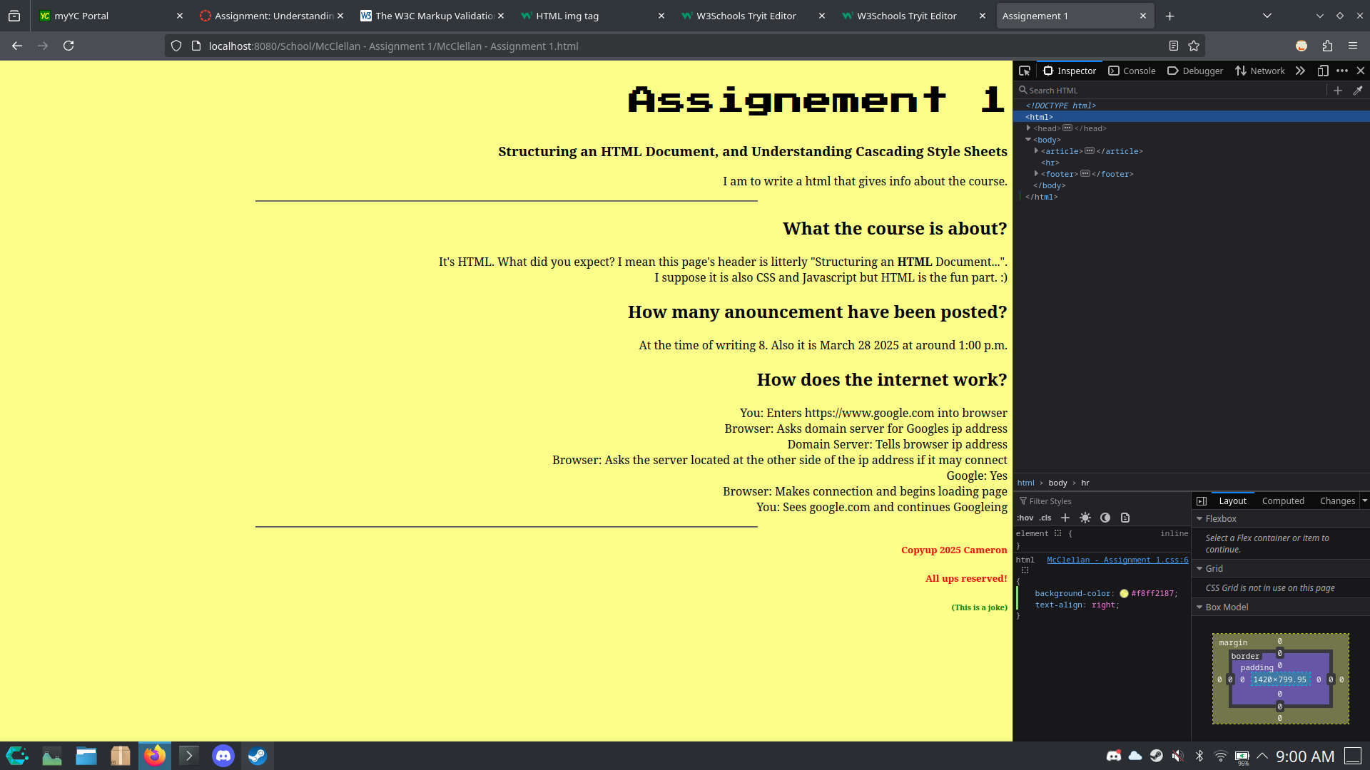
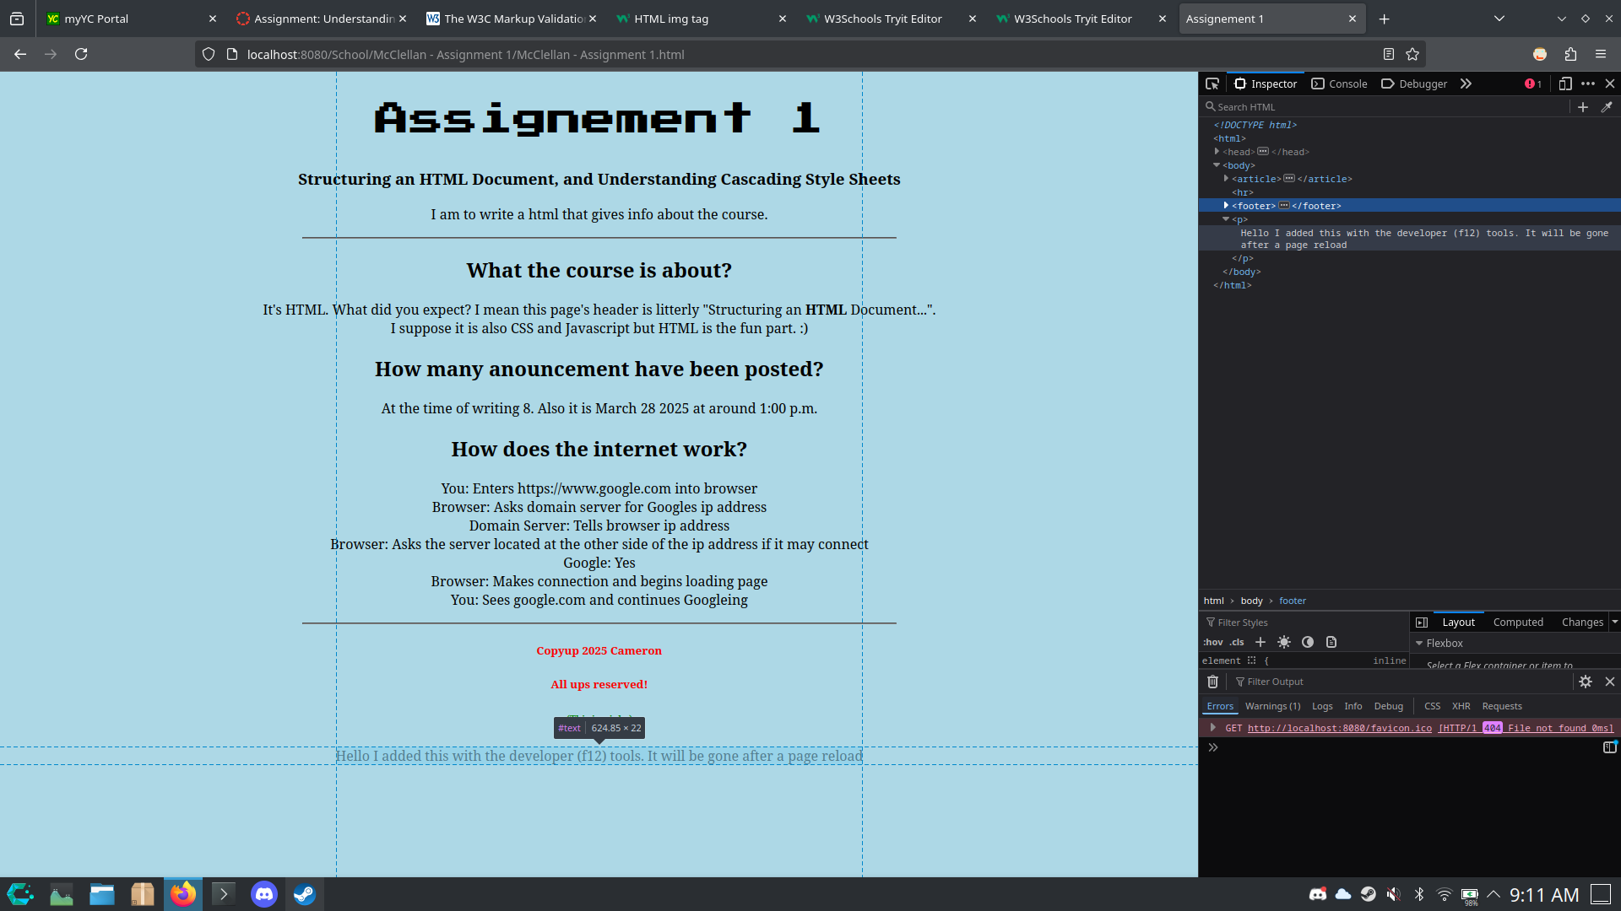
Edited CSS Changed the backround to yellow and alligned everything to the left

Edited HTML to add a paragraph at the bottom.

